INDIAN SCHOOL AL WADI AL KABIR
Class: VI | Department : Computer Science | Year :2023-2024
Holiday Homework | Topic: Excel-Functions & Formulas
1.Open Excel & Create a new worksheet.
2. Enter the following data
3. Using sum function calculate value for first 3 days(by relative cell reference)

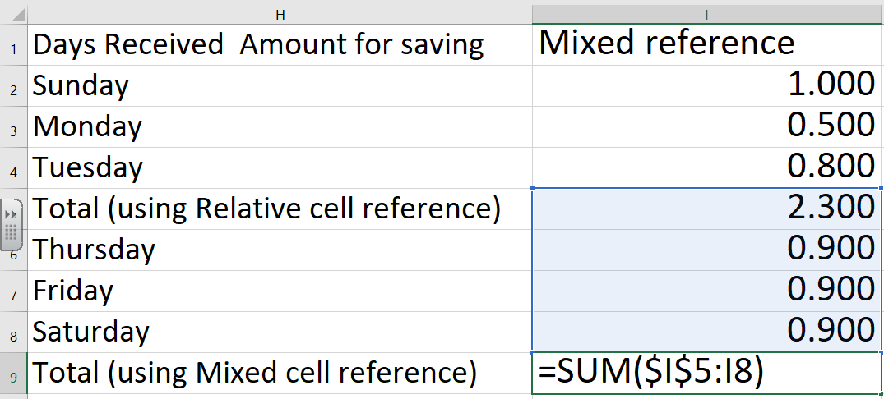

4. Using mixed cell reference complete and find total value saved for all six days
5. Using Date function find below values
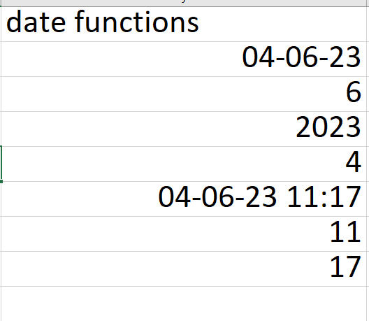
Note: Practice this worksheet , Evaluation will be done after holidays during practical session

